|  |  |
| --- | --- |
| NAME: _____________ | **Statistics** |
| Probability – Day 2 | **DATE: Wednesday, May 03, 2017** |



List below all the possible outcome (known as the sample space) when you roll 2 dice. (for example you could get a 1-6 or 6-1, which are different!) list them all.

It might help to make a tree diagram or a chart.

## Probability

Using the other side, find the theoretical probability of rolling:

|  |  |  |  |  |  |  |  |  |  |  |  |  |
| --- | --- | --- | --- | --- | --- | --- | --- | --- | --- | --- | --- | --- |
| Sum of | 1 | 2 | 3 | 4 | 5 | 6 | 7 | 8 | 9 | 10 | 11 | 12 |
| Theoretical Prob (as fraction) |  |  |  |  |  |  |  |  |  |  |  |  |

1. Now get 2 dice and roll them 100 times (each person on their own). Use the table below to fill in the tally, total and experimental probability.
2. Now with three partners, add those totals up and put the experimental totals of your group below. Then put the experimental probability
3. Compare to the theoretical probability (use the above table and put in as a percent)

## Experimental Probability

Roll the 2 dice 100 times and fill out the table below.

|  |  |  |  |  |  |  |
| --- | --- | --- | --- | --- | --- | --- |
|  | **Tally** | Total | **Exp.**  **Prob** | **In a group of 4 students add each total up** | **Experimental Probability of your group** | **Theoretical Probability**  **(from earlier)** |
| 2 |  |  |  |  |  |  |
| 3 |  |  |  |  |  |  |
| 4 |  |  |  |  |  |  |
| 5 |  |  |  |  |  |  |
| 6 |  |  |  |  |  |  |
| 7 |  |  |  |  |  |  |
| 8 |  |  |  |  |  |  |
| 9 |  |  |  |  |  |  |
| 10 |  |  |  |  |  |  |
| 11 |  |  |  |  |  |  |
| 12 |  |  |  |  |  |  |

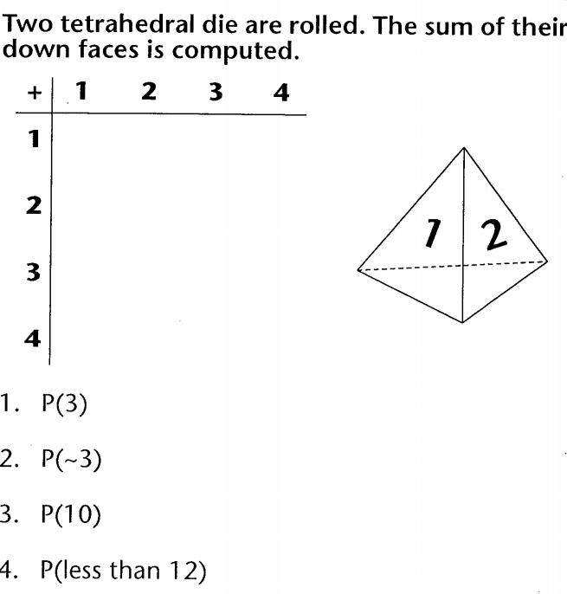

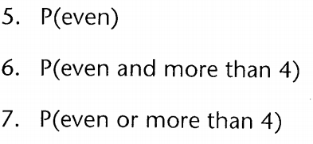

List the sample space:

