NAME: _____________ | Stats and probability
1-2b Stem and Leaf Plots | DATE: Wednesday, February 02, 2022

Together – data collection

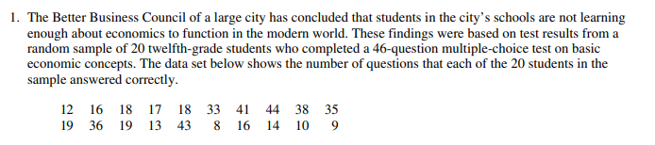

- Create a stem plot.
- What do you see in the data when you look at the stem plot? Write 2 sentences.

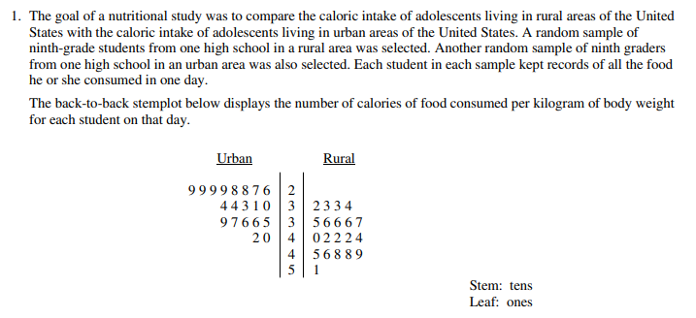
- How many urban students were in the sample?

- What is the least number of calories (per kg) did any urban student have? How about rural student?

- What differences do you see between how many calories an urban student has vs a rural student?

- Do you think we can make these conclusions (from question c) for all rural and urban students? Why or why not?

