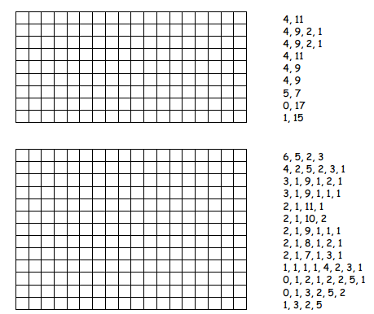
ECS 2 – Binary Pictures
If you want to produce coloured images you can use a number to represent the colour (e.g. 0 is black, 1 is red, 2 is green etc.) Two numbers are now used to represent a run of pixels: the first gives the length of the run as before, and the second specifies the colour.
Colors used: 0 White 1 red 2 orange 3 blue 4 brown
12,0,4,2
5,0,6,1,1,0,4,2
4,0,8,1,3,2
4,0,3,4,2,2,1,4,2,2,4,1
3,0,1,4,1,2,1,4,3,2,1,4,2,2,4,1
3,0,1,4,1,2,2,4,3,2,1,4,3,2,2,1
3,0,2,4,4,2,4,4,2,1
5,0,7,2,2,1
1,0,5,1,1,3,3,1,1,3,2,1
7,1,1,3,3,1,2,3,1,0,2,4
1,2,6,1,6,3,1,0,2,4
3,2,2,3,1,1,2,3,1,2,2,3,1,2,1,3,3,4
2,2,1,4,10,3,3,4
1,0,3,4,9,3,3,4
3,4,8,3
2,4,1,0,5,3

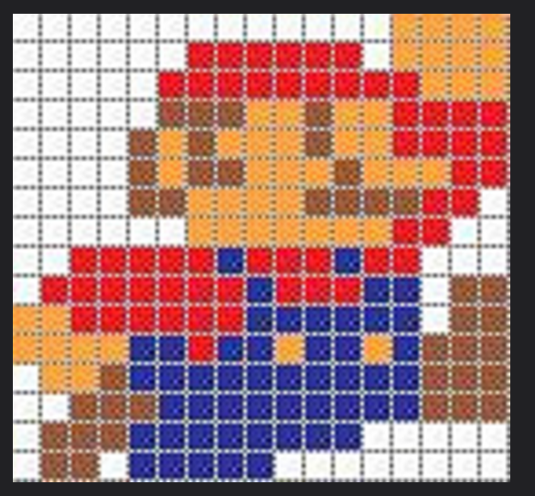
https://www.flickr.com/photos/36821880@N07/4290644088/

