NAME: _____________ | Statistics and Probability
Simulations | DATE: Tuesday, June 06, 2017
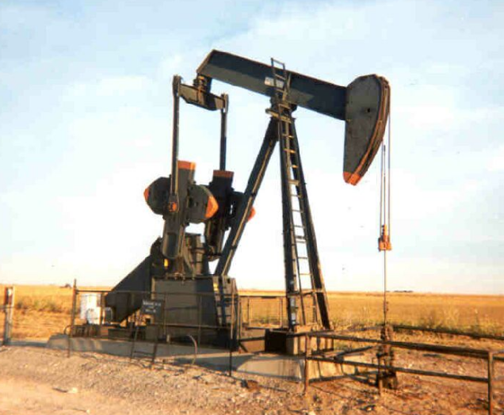
- Suppose the probability that an exploratory oil well will strike oil is about 0.2. Conduct a simulation to answer the following questions. Assume that the outcome (oil or no oil) for any one exploratory well is independent of outcomes from other wells. The company is going to drill until they reach oil. How many times will it take?
Conduct a simulation with 20 trials. Write your results from your trials below.

Using your simulation:
  - Estimate the average number of wells that need to be drilled in order to strike oil.

  - What is the probability that it will take fewer than 3 attempts to strike oil?

  - What is the probability that it will take exactly 6 wells to strike oil?

- A certain teacher has eight keys, but he never recalls which one fits his classroom oor. He tries one key at a time, each time choosing one of the keys at random from his pocket. (All the keys look the same but he does not put a key back in his pocket once he has tried that key.) How many keys will he likely need to do in order to unlock his door.
Conduct a simulation with 20 trials. Write your results from your trials below.

Using your simulation:
  - What is the expected number of tries needed for him to find the correct key?

  - What is the probability it will take more than 4 tries to find the right key?

- 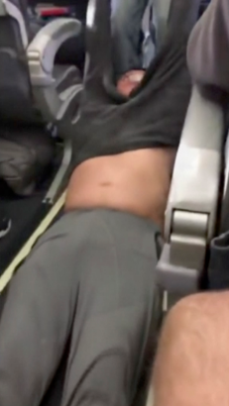An airline estimates that 8% of the time a person will mis s their flight for some reason(ie: weather). If there are 15 seats on the plan, and they sell 17 tickets, how many passengers are likely to show up?
Conduct a simulation with 20 trials. Write your results from your trials below.

Using your simulation:
  - What is the expected number of people that show up (out of the 17 people)?

  - What is the probability that at least one ticket-holder is denied a seat?

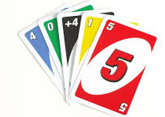
- At Uno, when someone plays a color that you don’t have, you have to keep drawing until you get one. Each time, you have ¼ chance of getting the right color (lets assume the deck is really, really large, so each time, the odds stay the same). How many cards do you expect it will take until you get that color you need.
Conduct a simulation with 20 trials. Write your results from your trials below.

Using your simulation:
  - What is the expected number of cards that you will need to pick up until you have one to play?

  - What is the probability that it will take more than 5 cards?

