NAME: _____________ | Prob and Stats
Yahtzee | DATE: Monday, June 05, 2017

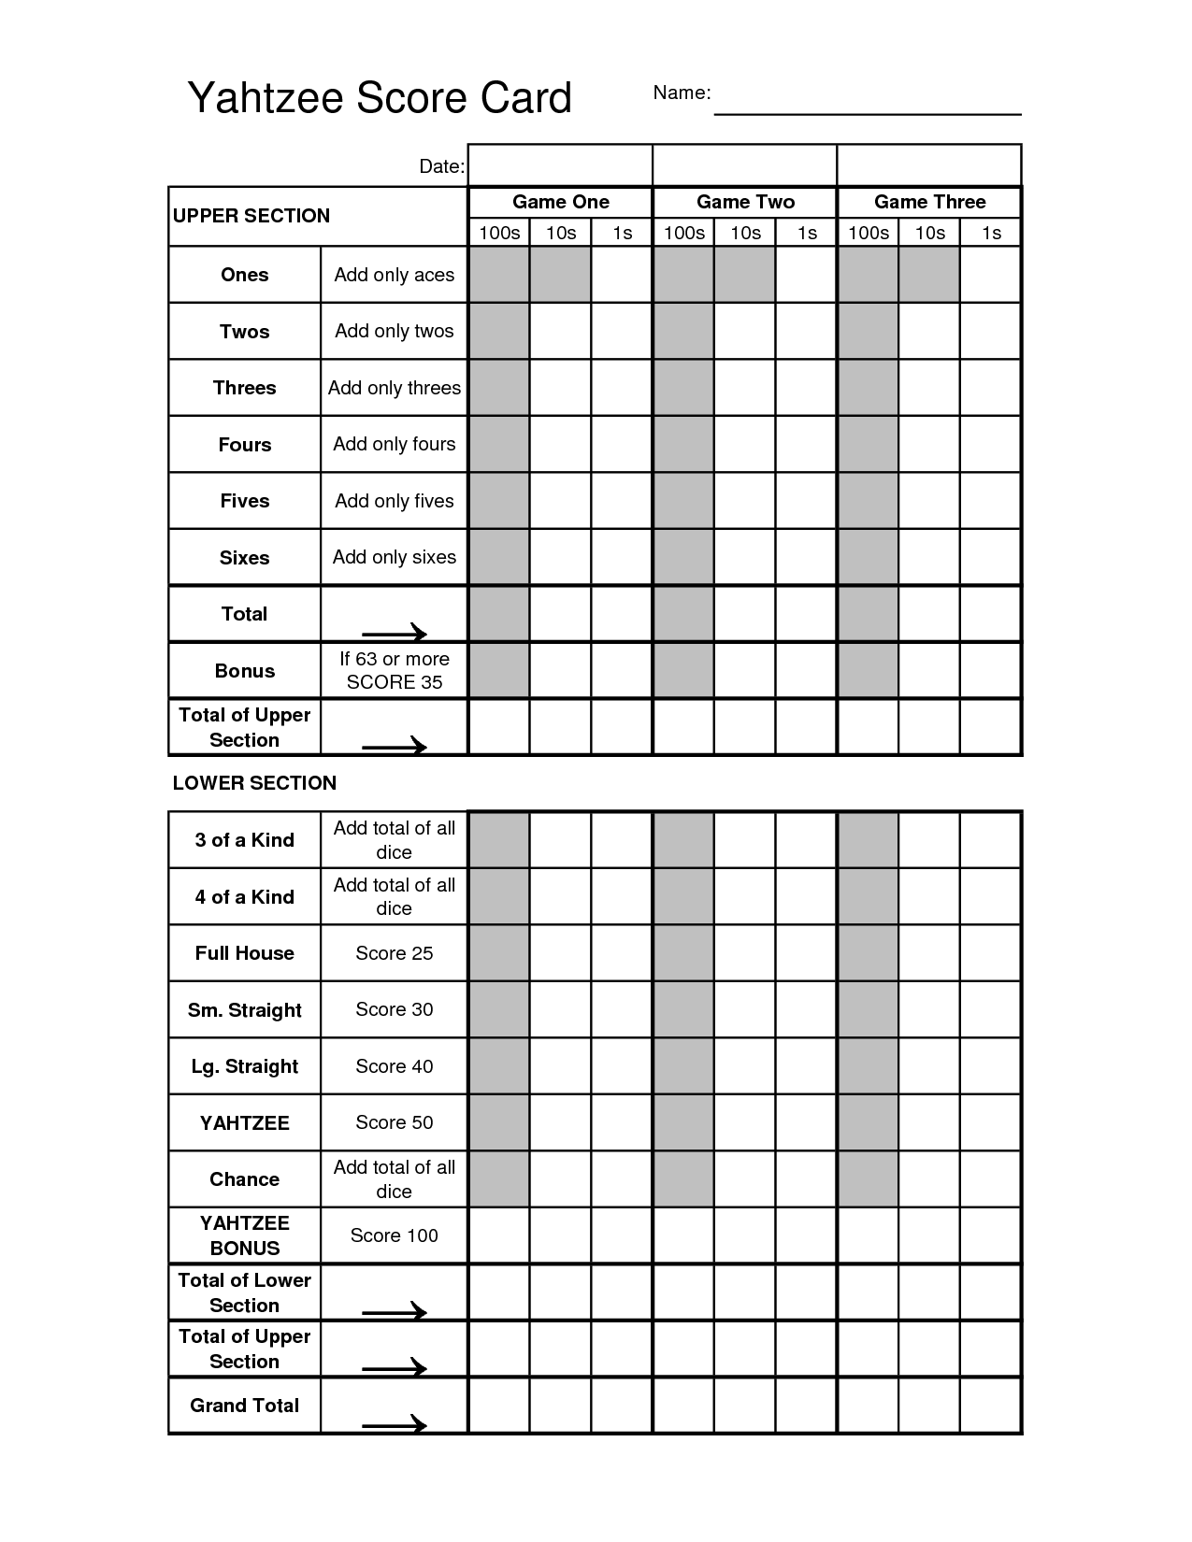Lets play Yahtzee using this board:

Now lets make a tree diagram for your chances of getting Yahtzee:
Yahtzee:
We are going to play yahtzee again, this time, the goal is just yahtzee. Play 50 times. Fill out the table below:

Yahtzee:
First roll number in common | # of times this happened | TALLY | # of Times you ended up with Yahtzee
0
1
2
3
4
5
TOTAL
As a class:
First roll number in common | Probability of this happening | Probability of getting yahtzee
0
1
2
3
4
5
TOTAL

PROBABILITY OF GETTING YAHTZEE IN TOTAL: ______

