NAME: _____________
Box Plots | DATE: Thursday, February 10, 2022

With your partner, grap 20 random pennies and mark their ages (2018-year) down below:

Find:
Mean: ______
Median: ______
Mode: ______

Now find these numbers:
Min: ______
Max: ______

Find the median of the numbers to the left of the median
(known as Quarter 1 – Q1): ______

Find the median of the numbers to the right of the median
(known as Quarter 3 – Q3): ______

Now draw a box plot:

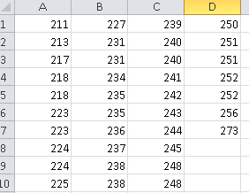
Do one more on your own: The NWEA scores of students in my stats class are below (in order):
Find 5 number summary:
Min:
Q1:
Median:
Q3:
Max:

HW Box Plots

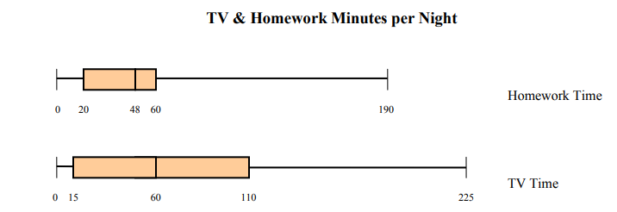

- What percent of students spent less than an hour on homework?
- What percent of students spent less than an hour on tv?
- What was the least amount of tv anyone watched?
- What was the most amount of homework anyone did?
- What was the median amount of homework students did?

There are 200 students in this survey.
- How many students spent less than 20 minutes on homework?
- How many students spent more than an hour on tv?

Create a box plot for the height (use total inches) and age of the Celtics roster.
NAME | AGE | HT | Total inches | WT
Payton Pritchard11 | 24 | 6' 1" | 73 | 195 lbs
Dennis Schroder71 | 28 | 6' 1" | 73 | 172 lbs
Marcus Smart36 | 27 | 6' 4" | 76 | 220 lbs
Romeo Langford9 | 22 | 6' 5" | 77 | 216 lbs
Aaron Nesmith26 | 22 | 6' 5" | 77 | 215 lbs
Josh Richardson8 | 28 | 6' 5" | 77 | 200 lbs
Brodric Thomas97 | 25 | 6' 5" | 77 | 185 lbs
Jaylen Brown7 | 25 | 6' 6" | 78 | 223 lbs
P.J. Dozier50 | 25 | 6' 6" | 78 | 205 lbs
Grant Williams12 | 23 | 6' 6" | 78 | 236 lbs
Sam Hauser30 | 24 | 6' 7" | 79 | 217 lbs
Jayson Tatum0 | 23 | 6' 8" | 80 | 210 lbs
Bruno Fernando28 | 23 | 6' 9" | 81 | 240 lbs
Al Horford42 | 35 | 6' 9" | 81 | 240 lbs
Robert Williams III44 | 24 | 6' 9" | 81 | 237 lbs
Enes Freedom13 | 29 | 6' 10" | 82 | 250 lbs
Bol Bol10 | 22 | 7' 2" | 86 | 220 lbs

